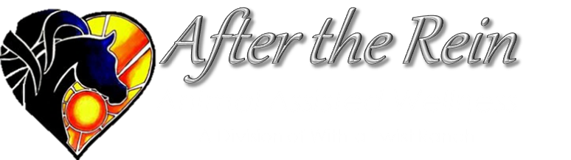
Waiver – Adult
ACKNOWLEDGMENT OF RISK AND RELEASE OF LIABILITY (AR-0103)
For Participants Over the Age of Majority in the Province of Alberta

WARNING: THIS AGREEMENT WILL AFFECT YOUR LEGAL RIGHTS. READ IT CAREFULLY!
Every Person Must Read and Understand this Waiver Before Participating in Equine Activities. The following waiver of all claims, release from all liability, assumption of all risks, agreement not to sue and other terms of this agreement are entered into by me (the Participant) with and for the benefit of
After the Rein Equine Assisted Wellness, With a Twist Ranch
its directors, officers, employees, volunteers, business operators, agents and site property owners, or lessees (collectively the "Host"). Without limiting the generality of the foregoing, "Equine Activities" includes but is not limited to ground exercises, trail rides and riding instructions provided by the "Host" to the Participant.
Initial Each Item below after Reading and Understanding each item:

_______1. I am aware that there are inherent dangers, hazards and risks (collectively "Risks") associated with "Equine Activities" and injuries resulting from these "Risks" are a common occurrence. I am aware that the "Risks" of "Equine Activities" mean those dangerous conditions which are an integral part of "Equine Activities", including but not limited to: (a) the propensity of any equine to behave in ways that may result in injury, harm or death to persons on or around them and to potentially collide with, bite or kick other animals, people or objects; (b) the unpredictability of an equine's reaction to such things as sounds, sudden movement, tremors, vibrations, unfamiliar objects, persons or other animals and hazards such as subsurface objects; (c) the potential for other participants to behave in a negligent manner that may contribute to injury to themselves or others, including failing to act within their abilities to maintain control over an equine.
_______2. I freely accept and fully assume all responsibility for all "Risks" and possibilities of personal injury, death, property damage or loss resulting from my participation in "Equine Activities".
_______3. I agree that although the "Host" has taken steps to reduce the "Risks" and increase the safety of the "Equine Activities", it is not possible for the "Host" to make the "Equine Activities" completely safe. I accept these "Risks" and agree to the terms of this waiver even if the "Host" is found to be negligent or in breach of any duty of care or any obligation to me in my participation in "Equine Activities".
_______4. In addition to consideration given to the "Host" for my participation in "Equine Activities", I and my heirs, next of kin, executors, administrators and assigns (collectively my "Legal Representatives") agree: (a) to waive all claims that I have or may have in the future against the "Host"; (b) to release and forever discharge the "Host" from all liability for any personal injury, death, property damage, or loss resulting from my participation in the equine activity due to any cause, including but not limited to negligence (failure to use such care as a reasonably prudent and careful person would use under similar circumstances), breach of any duty imposed by law, breach of contract or mistake or error in judgment of the "Host"; and (c) to be liable for and to hold harmless and indemnify the "Host" from all actions, proceedings, claims, damages, costs demands, including court costs and costs on a solicitor and own client basis, and liabilities of whatsoever nature or kind arising out of or in any way connected with my participation in "Equine Activities".
_______5. I agree that this waiver and all terms contained herein are governed exclusively and in all respects by the laws of the Province of Alberta. I hereby irrevocably submit to the exclusive jurisdiction of the courts of the Province of Alberta and I agree that no other court can exercise jurisdiction over the terms and claims referred to herein. Any litigation to enforce this waiver will be instituted in the Province of Alberta.
_______6. I confirm that I have had sufficient time to read and understand this waiver in its entirety. I understand that this agreement represents the entire agreement between myself and the "Host", and it is binding on myself and my "Legal Representatives".
_______7. I confirm that I have reached the age of majority in the province in which I am participating in "Equine Activities".
Please Print Clearly

Participant Name______ ______ _________ Date of Birth_____________________

Address__________________ _______________________________City_______ ___________Province___ Postal___ _____

Phone # (_______)____________ _______________ Email:_________ ____ _________________________________________

__________________________________________________ Signed this __ ___ day of ___ _________________, 20_ _ _
(Signature of Participant)

__________________________________________________
(Print Name of "Host" Witness to Signing and Initialing)

__________________________________________________ Signed this __ ___ day of ___ _________________, 20_ _ _
(Signature of "Host" Witness)

